Title: A Heuristic Algorithm for Quantifying Point-Pattern Disorder with Applications to Differentiation of Planned and Natural Point Collections

**Authors:** S. Jones1, H.G. Momm1*, R. ElKadiri1

**Affiliations:**

1Department of Geosciences, Middle Tennessee State University, Murfreesboro, Tennessee

*E-mail: Henrique.Momm@mtsu.edu

**Abstract:**

In any dataset the relationships between data points often contain information beyond the simple values associated with any single data point. For geographic data this idea is most commonly demonstrated with the concept of spatial autocorrelation, but many other techniques have been developed to quantify different conceptualizations of self-interaction and patterns within spatial data. We propose a new metric and related algorithm that describes the visual spatial disorder of geographic point sets, the “Index of Disorder”. The IoD algorithm was applied to multiple synthetic and three natural datasets and was shown to be able to differentiate between areas of high spatial disorder (randomly placed points) and low spatial disorder (e.g., curvilinear grids, chiral stamps and other repeating patterns). Because the IoD is a quantitative metric, it can be used either as an aid for identifying areas of unusually high or low spatial disorder, or as enrichment for machine learning classification algorithms.

**One Sentence Summary:**

The spatial disorder of a given point of data can be quantified by comparing the relative positions of that point’s neighbors to the relative positions of its neighbors’ neighbors.

**Introduction**

XX

**Related Work**

XX

**Implementation of the Algorithm**

A general outline of the algorithm is as follows. Given a set *S* of coordinate pairs[1], the IoD for an arbitrary point can be calculated as follows: find all points in *S* within a certain distance *r* of the point, the result of which is the point’s *neighborhood*. Then for each neighbor in this neighborhood, find the neighbor’s neighborhood. Register each point in the original neighborhood with a point in the neighbor’s neighborhood and calculate the total registration cost. The IoD is the mean of the registration costs for each neighborhood comparison.

This algorithm can be written in Python-style pseudocode to calculate the IoD for a set of points:

def index_of_disorder(point_set, radius):  
 disorder_scores = []  
  
 for point in point_set:  
 neighborhood = find_neighborhood(point_set, point, radius)  
 # get the subset of points in point_set within radius of point  
 comparison_scores = []  
  
 for neighbor in neighborhood:  
 comparison_neighborhood = find_neighborhood(point_set, neighbor, radius)  
 registrations = register_points(neighbor, comparison_neighborhood)  
 comparison_score = mean(registrations.registration_costs)  
 comparison_score.append(comparison_score)  
   
 disorder_score = mean(comparison_scores)  
 disorder_scores.append(disorder_score)  
  
 return disorder_scores

Because the IoD algorithm is a heuristic algorithm, there is no formal, most correct implementation. Changes to the algorithm that can affect the output include:

1. Registration Strategy

Registering points between a neighborhood and a comparison neighborhood generally involves optimizing the pairs such that some objective function is minimized. An obvious strategy is to minimize the sum of the Euclidean distances of the point-pairs, but this can lead to suboptimal registration when patterns are translated slightly between neighborhoods. Figure 2 demonstrates several registration strategies. In cases where a neighborhood being compared contains points with no obvious partners, the Euclidean strategy may lead to an “offset” in the registration, where most or all points are registered to seemingly incorrect points in order to account for points with no obvious partner.

Using an objective function that penalizes very poor matches less, such as the square root of the distance or the sigmoidal function in Figure 1 generally improves overall registration by allowing points with no obvious partners to register to one another, leaving the points with obvious matches free to register with the correct match.

1. Realignment

Though some patterns are do not vary as a function of space (such as the core pattern in Figure 3), others patterns rotate, transform, scale, and flip as one traverses their extent (such as the core pattern in Figure 13). Though the neighborhood at one end of such a pattern is related to the neighborhood at another, the neighborhoods may look to be in serious disagreement if they are directly compared. In such cases it may be necessary to transform one neighborhood to better match another. One strategy to do so application of the Iterative Closest Point algorithm to attempt to align the neighborhoods. As seen in Figure 2, successful alignment will significantly reduce the IoD when a similar pattern exists in the neighborhoods being compared. However, the realignment algorithms are not guaranteed to “correctly” align the neighborhoods. Furthermore, realigning neighborhoods may also lead to spurious depressions in the IoD even when no pattern similarity exists. If this spurious depression exceeds the reduction in IoD when true pattern correspondence exists then realignment will actually reduce the ability of the IoD to differentiate ordered and disordered point sets.

1. Scoring Function

Once two neighborhoods have been registered to one another, some function must be defined that relates the displacement between two registered points and a score describing the “goodness” of the match. The value of the displacement itself is not suitable because it has no upper bound and does not itself provide any explanatory power for how good the registration is; at large scales a large displacement could be considered acceptable noise in a pattern, but at smaller scales the same displacement would be more likely to indicate nonpattern. Necessarily, any attempts to quantify pattern similarity are scale-dependent.

In calculating the IoD, it is convenient to define a scoring function that has a lower bound of 0 (to describe no disorder) and an upper bound of 1 (to describe maximal disorder), though such a range is arbitrary. More important is selecting a function that is able to distinguish acceptable point-pair displacement (indicative of order) from excessive point-pair displacement (indicative of disorder) at the scale of interest. The sigmoidal function in Figure 1 is convenient as it can be made to punish excessive displacement beyond the midpoint *Km* while allowing for pattern noise by reducing punishment below *Km*. The degree to which displacements near *Km* are punished can be controlled by adjusting the *n*, which controls rapid the transition around *Km* occurs. Other scoring functions are possible, but the sigmoidal function’s properties make it useful for quantifying pattern similarity. Additionally, the same function can be used for scoring and for calculating registration cost.

1. Treatment of Unpaired Points

Neighborhoods being compared may not, and typically do not, have the same number of points. Many implementations of point set registration and realignment algorithms assume that the point sets being compared are of equal size though trivial modifications can be made to handle this case of unequal point set sizes. However, the output from such modified algorithms will necessarily result in the larger neighborhood having unpaired points, and a decision must be made about how to handle these unpaired points before calculating the registration cost.

The simplest option is the simply ignore unpaired points when calculating the mean registration cost. Though simple, this option would find that a neighborhood with few points has a low registration cost to an arbitrary neighborhood with many points because each point in the first neighborhood has a high likelihood of being matched with a very close point in the second neighborhood, leading to a potentially spurious depression of the IoD.

In order to prevent such spurious depression of the IoD, a second option is to penalize unmatched points by some arbitrary amount. Under this scheme, the IoD depression is reduced in cases where one neighborhood has many more points than a comparison neighborhood.

There are some circumstances where two neighborhoods may show the same pattern, but the pattern in one neighborhood is truncated because e.g., the neighborhood’s parent point lies at the edge of a pattern. In this case, punishing unpaired points would depress the IoD even though there is a relationship between the two neighborhoods. A third and generally superior option is to punish unpaired points if and only if they are within the convex hull defined by the set of points that are registered. This allows for patterns in compared neighborhoods to be of unequal spatial extent will still preventing noisy points from depressing the IoD.

**Methods**

An implementation of the IoD algorithm was used to evaluate the disorder of various synthetic and natural datasets.

**Synthetic Data**

The IoD algorithm was applied to 12 synthetically generated point sets (Figures 3 through 14), each consisting of a central area with an undisturbed pattern surrounded by the same pattern becoming increasingly disturbed with random noise beyond a certain distance from the origin.

Each synthetic point set was evaluated twice: with and without iterative closest point realignment, but with no other changes to algorithm parameters. For all synthetic datasets the algorithm used a sigmoidal scoring function, the scoring function was used as the objective function for point registration, unpaired points outside the convex hull were unpunished and unpaired points within the convex hull were punished with a score of 1. Scoring function cooperativity and *Km* remained constant between synthetic datasets but neighborhood radius varied.

**Planted Trees**

LiDAR was acquired for two stud areas: an apple orchard and surrounding forest approximately 4km northwest of Crab Orchard, TN, and a partially reforested zone approximately 1km northeast of Atwell airport in Mooresville, NC. *LASTools* was used to generate digital surface (first return) and digital elevation (bare earth) models from the LiDAR; digital height models, sometimes called canopy height models, were created by subtracting the digital elevation models from the corresponding digital surface models. Tree crown locations were extracted from the digital height models by using the Laplace of Gaussian blob detection function implemented in the Python package *scikit-learn* [1]*.*

Each tree crown point set was then evaluated using the IoD algorithm, and trees were classified as “ordered” (part of an orchard or planted forest) or “disordered” (naturally occurring) based on an arbitrary IoD threshold (Figure 15 and Figure 16). For both study areas the algorithm used a sigmoidal scoring function, the scoring function was used as the objective function for point registration, unpaired points outside the convex hull were unpunished and unpaired points within the convex hull were punished with a score of 1. Scoring function cooperativity, *Km* and neighborhood radius differed between the study areas.

A sensitivity test was conducted for the TN orchard by varying the neighborhood radius and sigmoidal scoring function’s *Km* (Table 1). The classification accuracy was quantified using Cohen's kappa coefficient (κ).

**Building Centroids**

Building footprints were obtained for the metropolitan Nashville area from the Tennessee Department of Finance and Administration’s GIS repository, from which building centroids were generated using QGIS software. The IoD algorithm was used to assess the disorder of these centroids (Figure 17).

**Results**

**Synthetic Data**

Plots showing the calculated IoD for the synthetic data sets can be seen in Figures 3 through 14. The calculated IoD shows differentiation between the ordered and perturbed portions of all synthetic datasets, though the level of differentiation varies depending on the nature of the pattern. Patterns that are relatively space-invariant, such as the grid-based patterns in Figures 3, 4, 5 and 6 display the greatest degree of differentiation. In contrast, the highly heterogenous patterns in Figures 10 and 11 show only mild differentiation in the IoD. In general, differentiation is not significantly improved, and is sometimes worsened, by the application of a reorientation procedure during the scoring process. The exception to this are the “stamp-based” patterns, shown in Figures 12 and 13.

**Planted Trees**

Figure 15 shows the calculated IoD and IoD-based classifications for the orchard near Crab Orchard, TN. Figure 16 shows the calculated IoD and IoD-based classifications for the reforested zone near Atwell airport in Mooresville, NC. Table 1 shows Cohen’s κ as function of the *Km* of the scoring function and the radius of neighborhood for the classification of the trees in the Tennessee orchard. Peak accuracy (κ = 0.81) is achieved with a *Km* of 5 and a neighborhood radius between 70 to 80 meters. The IoD achieves significant overall visual differentiation between the planted and natural zones in both study areas.

**Building Centroids**

Figure 17 shows a map showing the IoD of building centroids in metropolitan Nashville, TN. Gridded residential areas overall have a low IoD, while industrial and commercial areas have a high IoD. Within residential areas, auxiliary buildings on residential properties show an elevated IoD compared to the buildings they are surrounded by.

**Discussion**

XX

**Conclusion**

XX

**Tables and Figures**

Table . Sensitivity test for Study Area 1 (Rowell’s Apple House near Crab Orchard, TN) with an IoD threshold of 0.8. Optimal results are obtained when a neighborhood radius is selected that is similar to the scale of the expected pattern, and a $K_{m}$ is selected that is similar to the scale of the expected pattern deviations. An excessively small $K_{m}$ results in oversensitivity to pattern noise and thus ordered points as classified as disordered, while an excessively large $K_{m}$ results in underdiscrimination against disorder and thus disordered points are classified as ordered.





Figure . An example of a sigmoidal scoring function, $s= \frac{d^{n}}{{k_{m}}^{n}+ d^{n}}$, where d is the point-pair deviation, n is the function cooperativity and $K_{m}$ is the deviation midpoint. An n of 1 will create a hyperbolic function, while values greater than 1 will make the function increasingly sigmoidal. The value of $K_{m}$ is the value of d at which $s=0.5$; this is represented by the dashed green lines. This equation is commonly used in biochemical investigations to model enzyme kinetics, where it is known as the Hill equation and $K_{m}$ is known as the Michaelis-Menten constant.



Figure . Visualization of the neighborhood comparison portion of the IoD algorithm. The neighborhood radius is shown for both the red and blue point in the upper left figure. The remaining three figures explore various point registration methods and the calculated IoD. Each registration subfigure shows the neighborhood corresponding to the red point in red and the neighborhood corresponding to the blue point in blue. Black lines connect a red neighborhood point to the blue neighborhood point it is registered to under the applied registration scheme. Euclidean registration attempts to minimize the sum of the lengths of the black lines. The alternative registration scheme attempts to minimize the sum of the scores of the registration lengths using the sigmoidal scoring function in Figure 1. The ICP realignment iteratively rotates, scales and translates the blue neighborhood to attempt to minimize the registration cost. The green polygon represents the convex hull of the registered points. In this example, unregistered points outside the convex hull are ignored for the purpose of scoring while unpaired points within the convex hull are penalized with a score of 1; paired points are scored using the scheme from Figure 1 regardless of the registration scheme used.

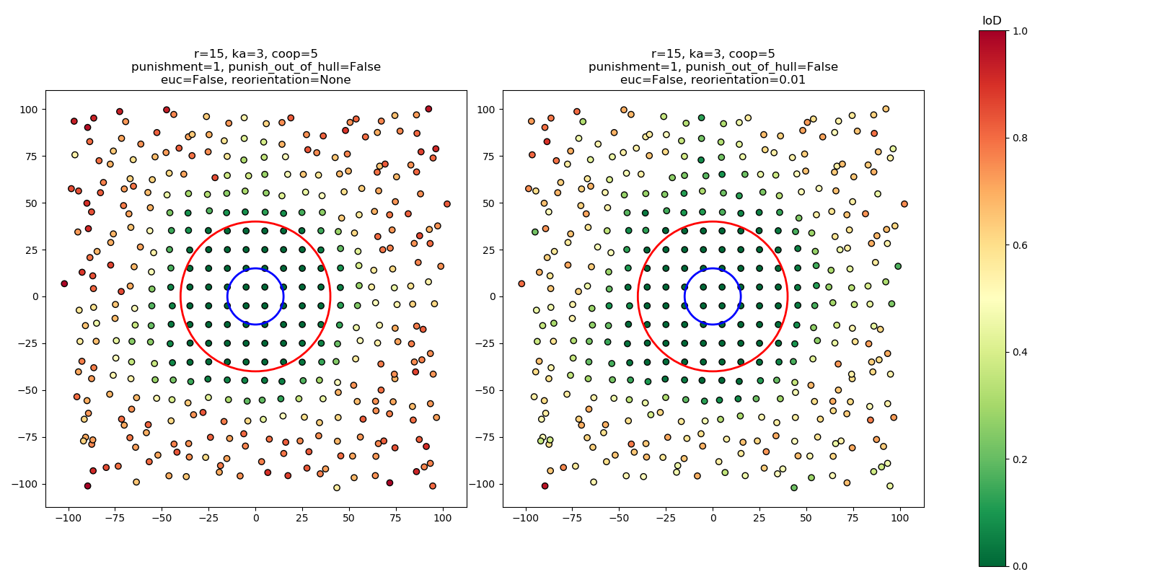

Figure . Results from applying two versions of the IoD algorithm without and with realignment (left and right respectively) to a square grid. The pattern is perturbed with random noise that increases in strength as a function of distance beyond the red circle, and the blue circle represents the neighborhood size.

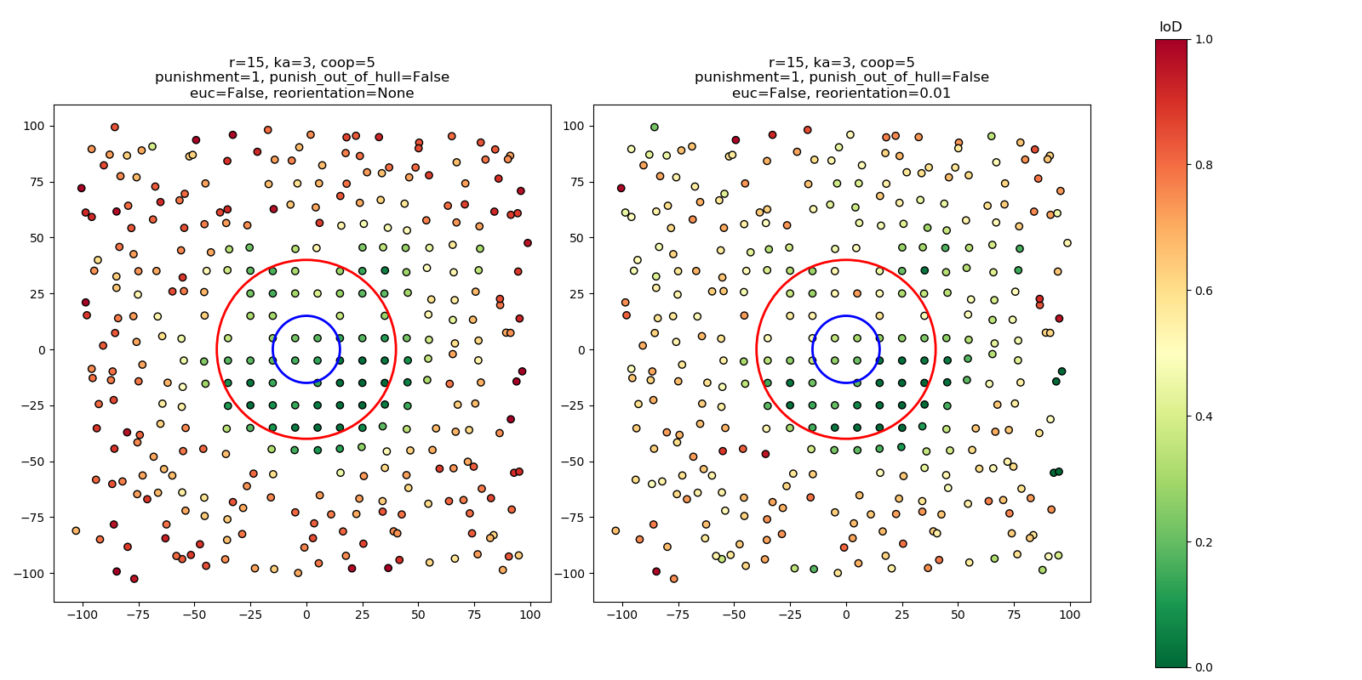

Figure . Results from applying two versions of the IoD algorithm without and with realignment (left and right respectively) to a square grid with 10% of the points randomly removed. The pattern is perturbed with random noise that increases in strength as a function of distance beyond the red circle, and the blue circle represents the neighborhood size.

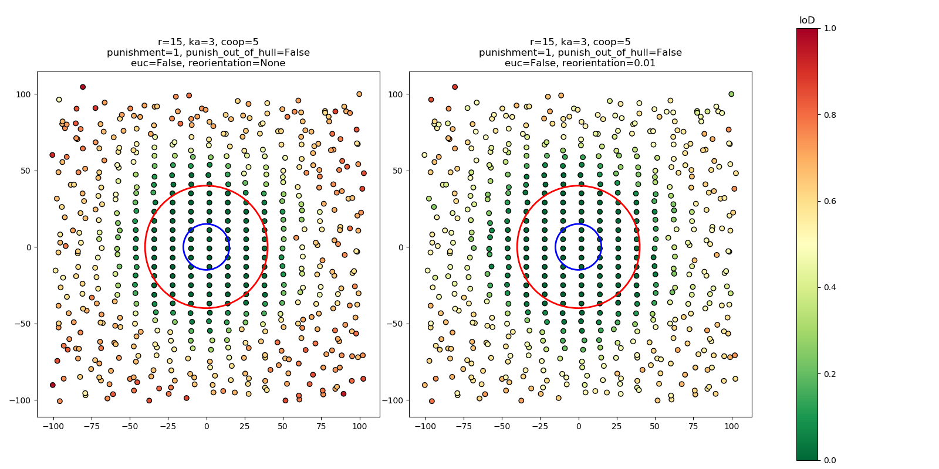

Figure . Results from applying two versions of the IoD algorithm without and with realignment (left and right respectively) to a rectangular grid. The pattern is perturbed with random noise that increases in strength as a function of distance beyond the red circle, and the blue circle represents the neighborhood size.

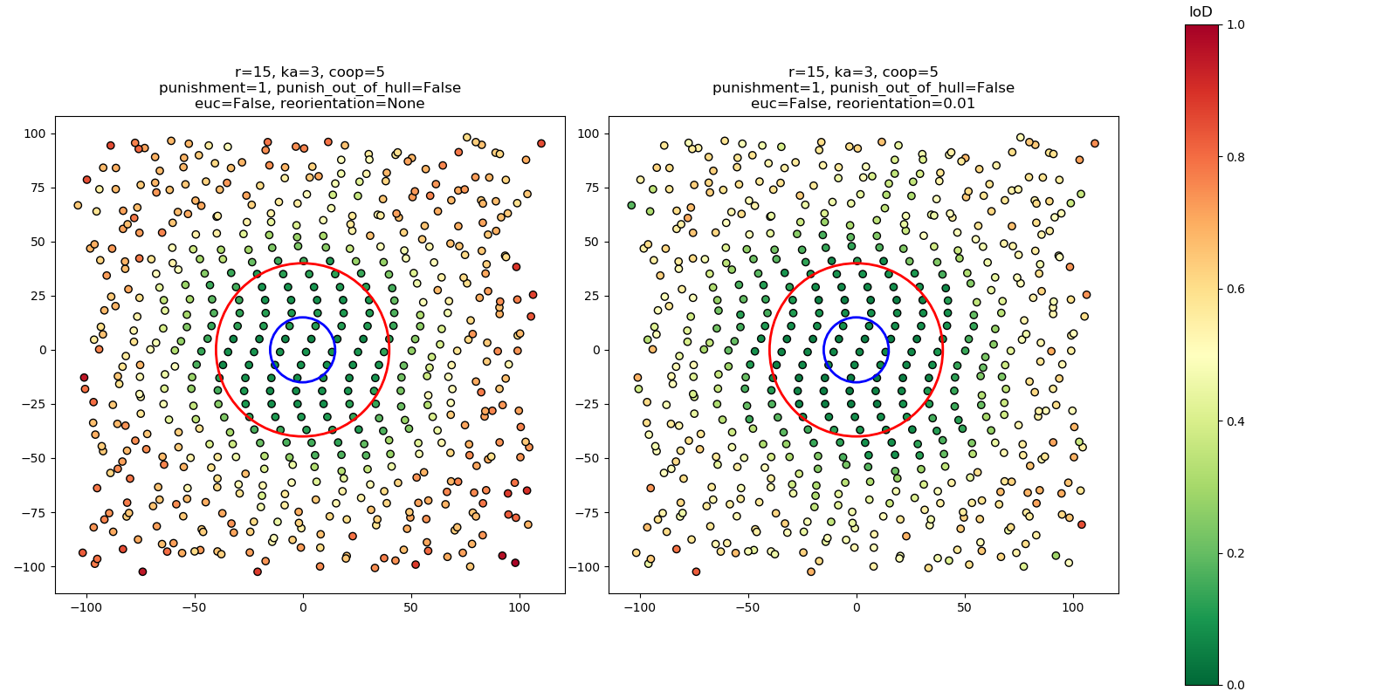

Figure . Results from applying two versions of the IoD algorithm without and with realignment (left and right respectively) to a rectangular grid modified with a sinusoidal signal. The pattern is perturbed with random noise that increases in strength as a function of distance beyond the red circle, and the blue circle represents the neighborhood size.

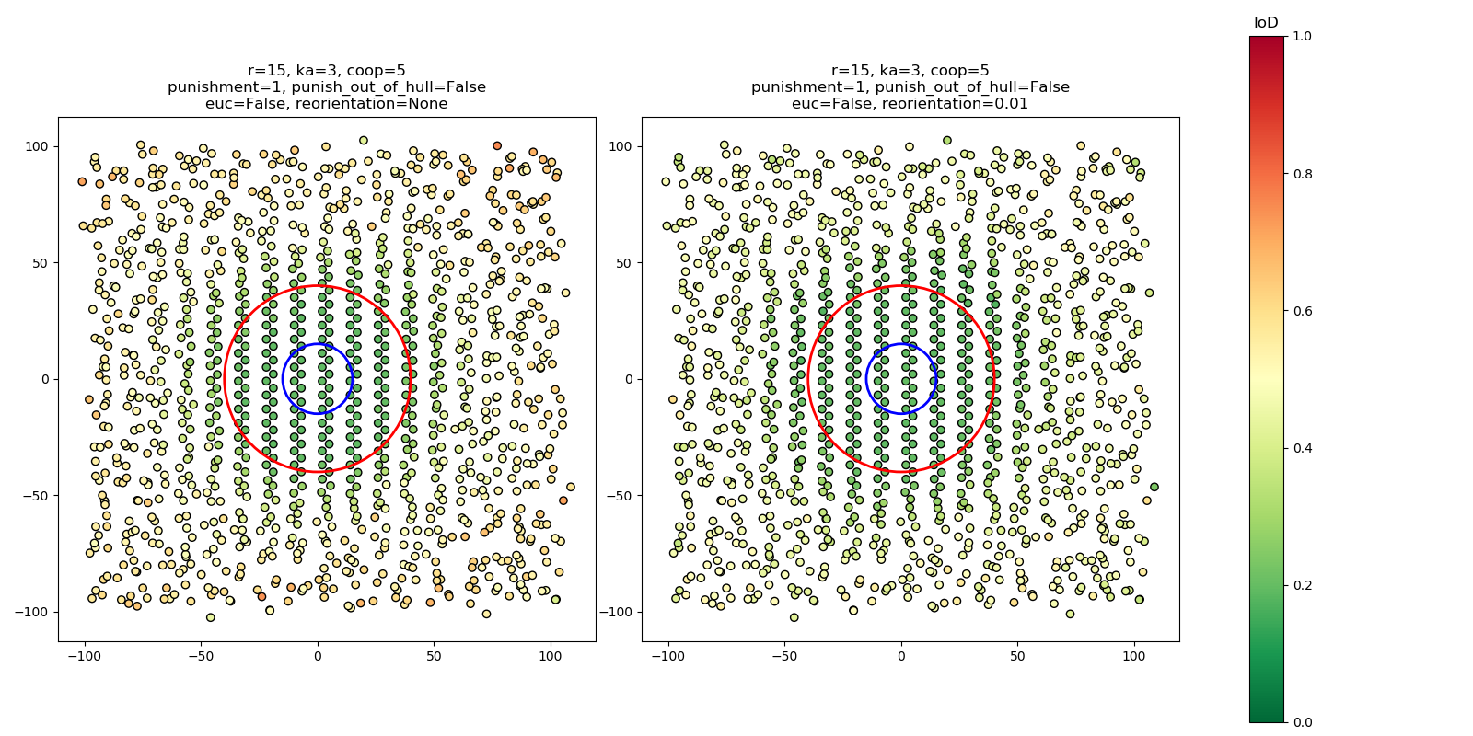

Figure . Results from applying two versions of the IoD algorithm without and with realignment (left and right respectively) to a pattern formed by overlapping two offset rectangular grids. The pattern is perturbed with random noise that increases in strength as a function of distance beyond the red circle, and the blue circle represents the neighborhood size.

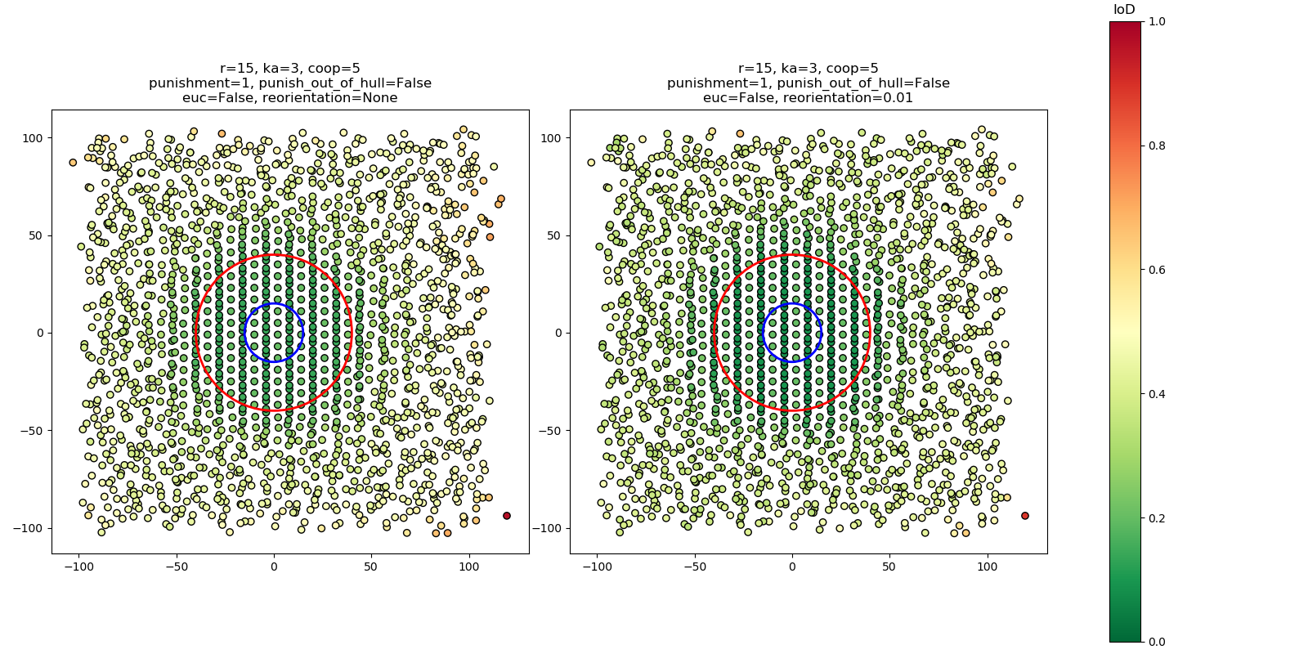

Figure . Results from applying two versions of the IoD algorithm without and with realignment (left and right respectively) to a pattern formed by overlapping three offset rectangular grids. The pattern is perturbed with random noise that increases in strength as a function of distance beyond the red circle, and the blue circle represents the neighborhood size.

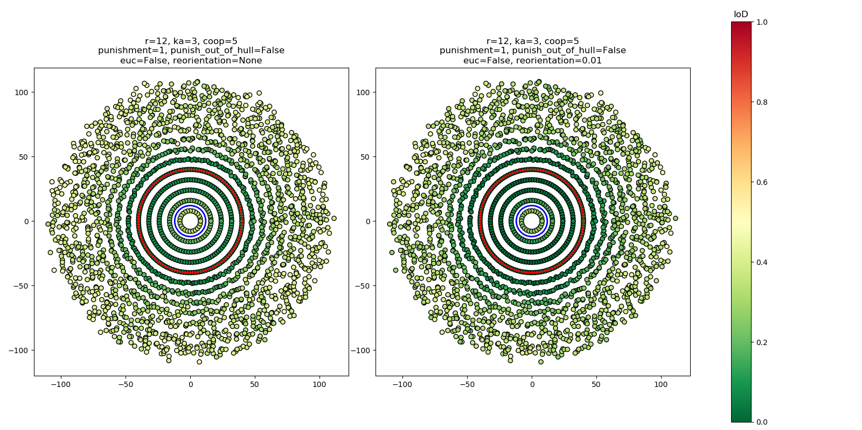

Figure . Results from applying two versions of the IoD algorithm without and with realignment (left and right respectively) to a pattern formed by overlaying concentric circles with equal linear point densities. The pattern is perturbed with random noise that increases in strength as a function of distance beyond the red circle, and the blue circle represents the neighborhood size.

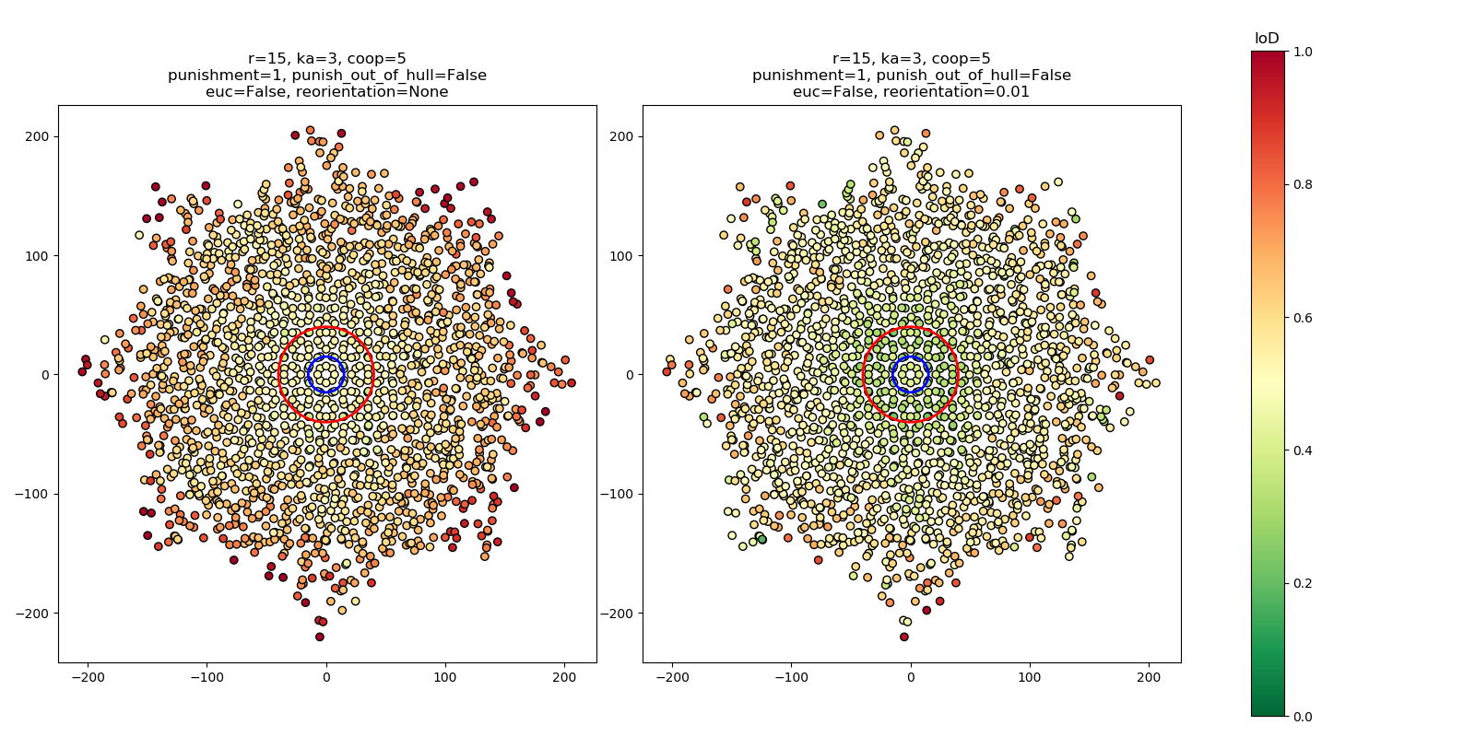

Figure . Results from applying two versions of the IoD algorithm without and with realignment (left and right respectively) to a pattern formed by overlapping a square grid with a copy of the same grid rotated 45 degrees. The pattern is perturbed with random noise that increases in strength as a function of distance beyond the red circle, and the blue circle represents the neighborhood size.

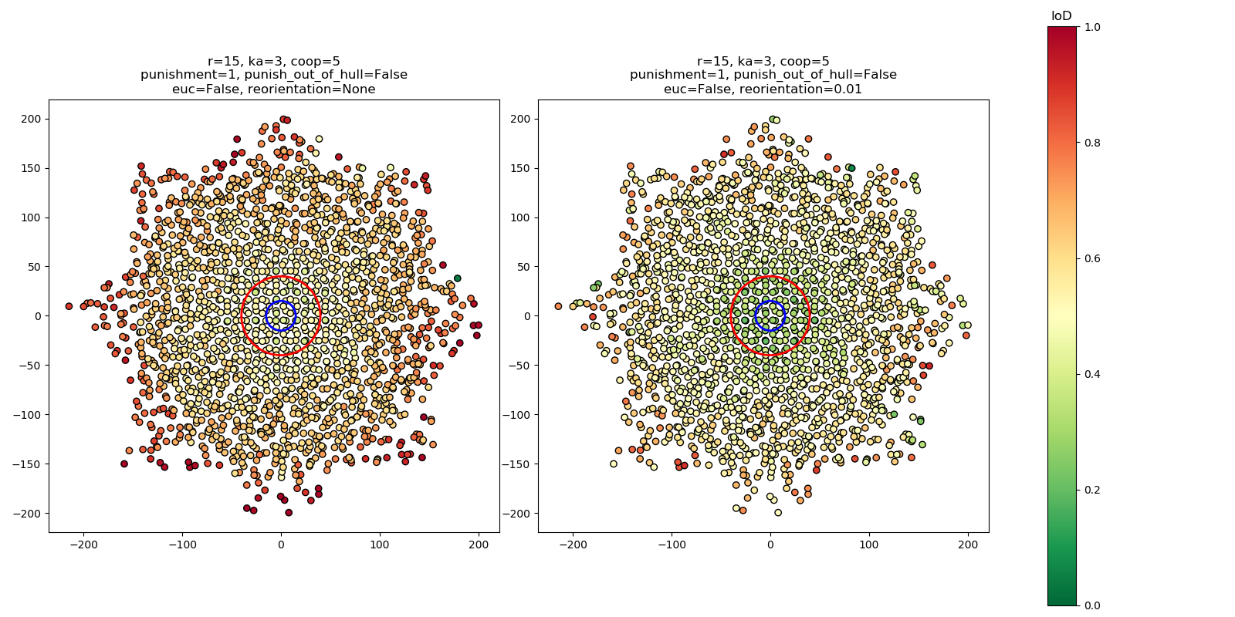

Figure . Results from applying two versions of the IoD algorithm without and with realignment (left and right respectively) to a pattern formed by overlapping a square grid with a copy of the same grid rotated 45 degrees and translated slightly. The pattern is perturbed with random noise that increases in strength as a function of distance beyond the red circle, and the blue circle represents the neighborhood size.

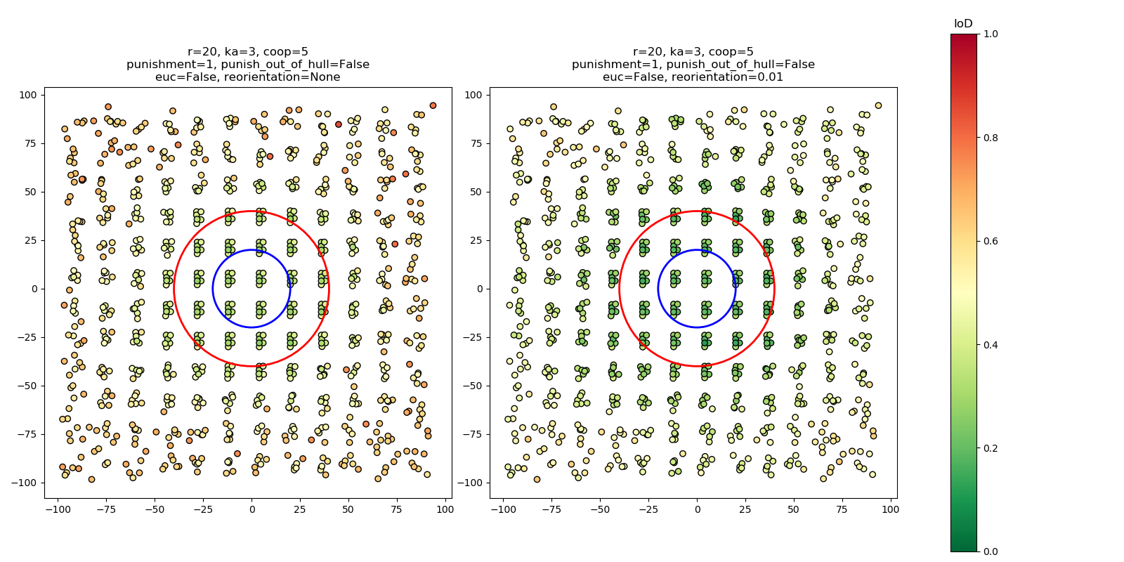

Figure . Results from applying two versions of the IoD algorithm without and with realignment (left and right respectively) to a pattern that consists of a repeating “stamped” unit. The pattern is perturbed with random noise that increases in strength as a function of distance beyond the red circle, and the blue circle represents the neighborhood size.

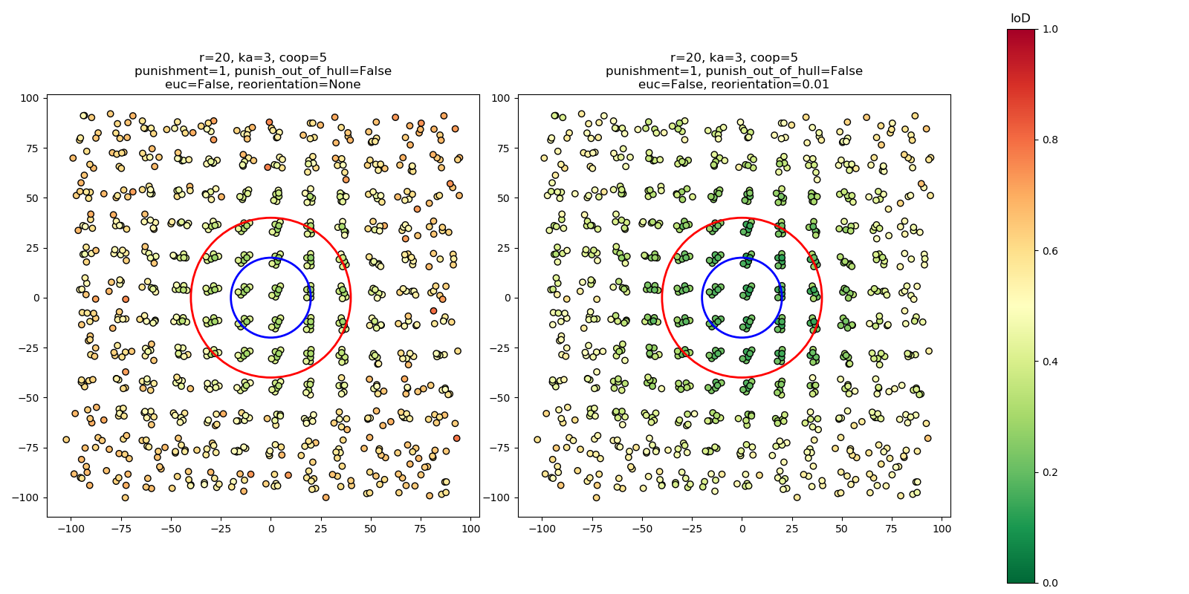

Figure . Results from applying two versions of the IoD algorithm without and with realignment (left and right respectively) to a pattern that consists of a repeating “stamped” unit that is continuously rotated. The pattern is perturbed with random noise that increases in strength as a function of distance beyond the red circle, and the blue circle represents the neighborhood size.

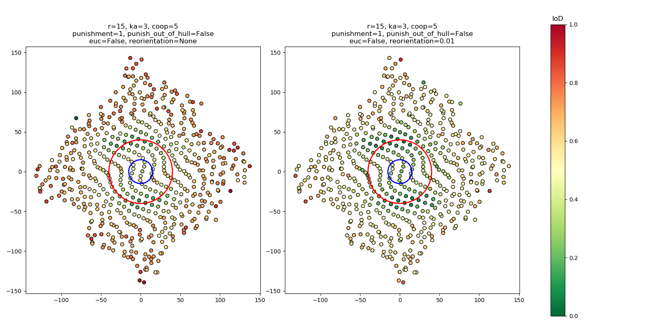

Figure . Results from applying two versions of the IoD algorithm without and with realignment (left and right respectively) to a rectangular grid that has been modified by two sinusoidal signals with different directionality. The pattern is perturbed with random noise that increases in strength as a function of distance beyond the red circle, and the blue circle represents the neighborhood size.



Figure . Results from applying the IoD to trees extracted from a DHM of Rowell’s Apple House, an orchard near Crab Orchard, TN. Axis units are in meters.



Figure . Results from applying the IoD to trees extracted from a DHM of a mixed planted and natural forest stand near Mooresville, NC. Axis units are in feet.

All Figures and Tables should be cited in order, including those in the Supplementary

Figure . A map of building centroids in metropolitan Nashville, TN. Centroids were evaluated with the IoD algorithm with a radius of 100 meters, a Km of 10 meters and an n of 5.

**References**

|  |  |
| --- | --- |
| [1] | F. Pedregosa, G. Varoquaux, A. Gramfort, V. Michel, B. Thirion, O. Grisel, M. Blondel, P. Prettenhofer, R. Weiss, V. Dubourg, J. Vanderplas, A. Passos and D. Cournapeau, "Scikit-learn: Machine Learning in Python," *Journal of Machine Learning Research,* vol. 12, pp. 2825-2830, 2011. |
| [2] | B. Jiang and J. Yin, "Ht-Index for Quantifying the Fractal or Scaling Structure of Geographic Features," *Annals of the Association of American Geographers,* vol. 104, no. 3, pp. 530-504, 2013. |
| [3] | A. Getis, "A History of the Concept of Spatial Autocorrelation: A Geographers Perspective," *Geographical Analysis,* vol. 40, no. 3, pp. 297-309. |
| [4] | P. Dong, "Lacunarity for Spatial Heterogeneity Measurement in GIS," *Annals of GIS,* vol. 6, no. 1, pp. 20-26, 2000. |
| [5] | E. Williams and E. Wentz, "Pattern Analysis Based on Type, Orientation, Size, and Shape," *Geographical Analysis,* vol. 40, no. 2, pp. 97-122, 2008. |
| [6] | S. Shekhar, M. Evans, J. Kang and P. Mohan, "Identifying patterns in spatial information: A survey of methods," *Wiley Interdisciplinary Reviews: Data Mining and Knowledge Discovery,* vol. 1, no. 3, pp. 193-214, 2011. |
| [7] | M. Herold, H. Couclelis and K. C. Clarke, "The role of spatial metrics in the analysis and modeling of urban land use change," *Computer, Environment and Urban Systems,* vol. 29, no. 4, pp. 369-399, 2005. |
| [8] | H. Momm, G. Easson and J. Kuszmaul, "Evaluation of the use of spectral and textural information by an evolutionary algorithm for multi-spectral imagery classification," *Computers, Environment and Urban Systems,* vol. 33, no. 6, pp. 463-471, 2009. |
| [9] | S. Baena, J. Moat, O. Whaley and D. S. Boyd, "Identifying species from the air: UAVs and the very high resolution challenge for plant conservation," *PLoS One,* vol. 12, no. 11, 2017. |
| [10] | X. Huang, H. Liu and L. Zhang, "Spatiotemporal Detection and Analysis of Urban Villages in Mega City Regions of China Using High-Resolution Remotely Sensed Imagery," *IEEE Transactions on Geoscience and Remote Sensing,* vol. 53, no. 7, pp. 3639-3657, 2015. |
| [11] | M. Pauly, N. J. Mitra, J. Wallner, H. Pottmann and L. Guibas, "Discovering structural regularity in 3D geometry," *ACM Transactions on Graphics,* vol. 27, no. 3, 2008. |
| [12] | B. P. Buttenfield, "Scale-Dependence And Self-Similarity In Cartographic Lines," *Cartographica: The International Journal for Geographic Information and Geovisualization,* vol. 26, no. 1, pp. 79-100, 1989. |
| [13] | T. Chang and C.-C. Kuo, "Texture analysis and classification with tree-structured wavelet transform," *IEEE Transactions on Image Processing,* vol. 2, no. 4, pp. 429-441, 1993. |

**Acknowledgments:** Acknowledgments follow the references and notes but are not numbered. Acknowledgments should be gathered into a paragraph after the final numbered reference. This section should start by acknowledging non-author contributions and then should provide information under the following headings:

**Funding:** include complete funding information, including grant numbers;

**Author contributions:** a complete list of contributions to the paper [we encourage you to follow the [CRediT](http://docs.casrai.org/CRediT) model]

**Data and materials availability:** All code used in the analysis for this paper is publicly available at <https://github.com/rsjones94/point-disorder>. The digital height models used to generate the tree crown datasets are available on request.

1. Though the IoD algorithm can be generalized to a set of points in an *n­*-dimensional space, this paper explores only the 2-dimensional implementation.